**Experiment: 1**

**Aim:** Write a Java program that prompts the user for an integer and then prints out all the prime numbers up to that Integer.

**Software:** VS Code

**Code:-**

import java.util.*;

public class Programm1

{

    public static void main(String args[])

    {

        Scanner sc = new Scanner (System.in);

        int n,j,i;

        System.out.print("Enter The Number:-");

        n = sc.nextInt();

        for(i=2;i<=n;i++)

        {

            for(j=2;j<i;j++)

            {

                if(i%j==0)

                {

                    break;

                }

            }

            if(i==j)

            {

                System.out.print(i + " ");

            }

        }

    }

}

**Output:**

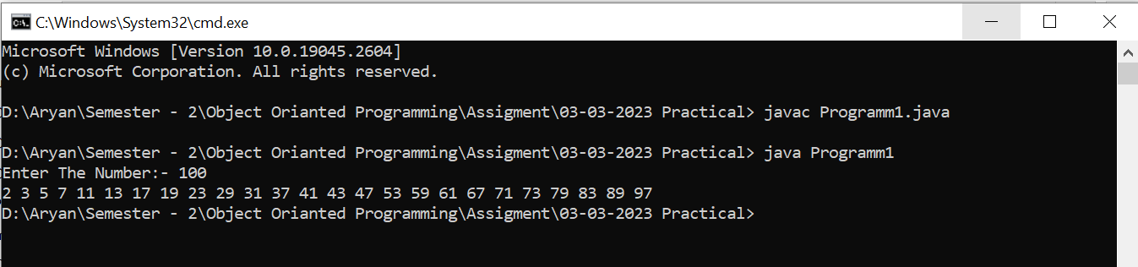

**Experiment: 2**

**Aim:** Write a java program to find the Fibonacci series using non-recursive  
Functions.

**Software:** VS Code

**Code:**

import java.util.*;

public class Programm2

{

    public static void main (String args[])

    {

        Scanner sc = new Scanner (System.in);

        int a=0,b=1,num;

        System.out.print("Enter Till How Many Terms You Want The Fibonacci Series ?");

        num = sc.nextInt();

        System.out.print(a + " " + b + " ");

        Fibonacci(num);

    }

    public static  void Fibonacci(int num)

    {

        int a=0,b=1,c;

        for(int i=1;i<=num;i++)

        {

            c = a + b;

            System.out.print(c + " ");

            a=b;

            b=c;

        }

    }

}

**Output:**

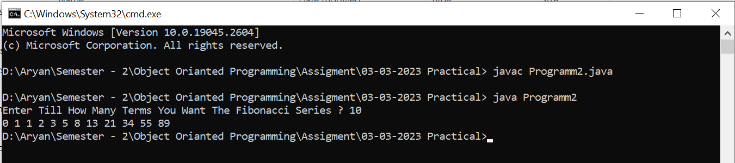

**Experiment: 3**

**Aim:** Write a java program to find the Fibonacci series using recursive Functions.

**Software:** VS Code

**Code:-**

import java.util.* ;

public class Programm3

{

    public static void main(String args[])

    {

        Scanner sc =new Scanner (System.in);

        int num,a=0,b=1;

        System.out.println("Enter Till How Many Terms You Want The Fibonacci Series?");

        num = sc.nextInt();

        System.out.print(0 + " " + 1 + " ");

        int c = Fibonacci(a,b,num);

        System.out.print(c + " ");

    }

    public static int  Fibonacci(int x,int y,int num)

    {

        num--;

        int z=x+y;

        if(num<=2)

        {

            return x + y ;

        }

        else

        {

            System.out.print(z + " ");

            return  Fibonacci(y,z,num) ;

        }

    }

}

**Output:**

